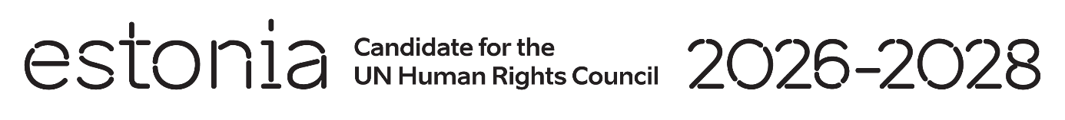

**Universal Periodic Review of Norway**

**4 November 2024**

**Intervention by the delegation of Estonia**

Estonia welcomes the delegation of Norway to its fourth UPR and its engagement with the UPR process. We commend Norway’s strong commitment to international law and to the protection and promotion of human rights globally, including throughout its development cooperation.

We praise Norway's long efforts in promoting gender equality, upholding media freedom, and supporting the fight against impunity for atrocity crimes. We welcome the Government’s action to promote safer internet use for children and young people.

We recommend to:

* ensure the compliance of the Child Welfare Service with human rights of both the parents and the child, taking fully into consideration the relevant ECHR (European Court of Human Rights) judgements;
* ratify the Kampala Amendments to the Rome Statute on the crime of aggression.

We wish the delegation of Norway a successful review meeting.

Thank you!