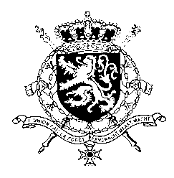
Représentation permanente de la Belgique auprès des Nations Unies et auprès des institutions spécialisées à Genève

WG UPR 47 – Norway
Belgian intervention
4 November 2024

President,
Belgium commends Norway for its commitment to human rights and on the progress made in implementing the recommendations made during its last UPR, in particular its ratification of the International Convention for the Protection of all Persons from Enforced Disappearance, its efforts to tackle domestic violence and the progress made in the fight against discrimination and hate crime.
In order to make further progress on human rights, particularly regarding women's and children’s rights , Belgium recommends the government of Norway to:
R1. Amend the definition of rape for it to be based on lack of consent, instead of use of force or threat, in line with international standards
R2. Continue the implementation and monitoring of measures to combat gender-based violence, domestic violence and sexual abuse and provide support for victims
R3. Ensure that the best interests of the child are placed at the core of its policies in relation to child welfare, and that adequate safeguards are available to guarantee compliance with the fundamental rights of both parents and children.
Thank you.

