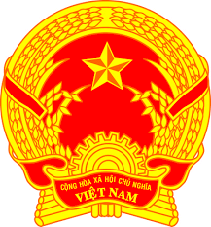

**Statement of the Socialist Republic of Viet Nam**

*47th Session of the UPR Working Group  
Review of Dominica*

*(Geneva, 7 November 2024)*

*Mister Vice-President,*

Viet Nam warmly welcomes the delegation of Dominica and appreciates the detailed national UPR report presented.

We commend Dominica for its dedication to advancing human rights, particularly through its efforts in climate resilience and legislative updates, such as the recent enactment of the Suite of Family Laws, which reflect a commitment to protecting vulnerable groups, including women, children, and persons with disabilities.

In a spirit of constructive dialogue, Viet Nam would like to offer the following three recommendations to Dominica:

1. First, strengthen social protection programs to enhance support for the elderly, persons with disabilities, and low-income families, ensuring their access to essential services like housing, healthcare, and emergency support, particularly in the face of climate-related challenges.

2. Second, promote digital and technological inclusion in education by increasing resources and infrastructure for youth, especially in rural and minority communities.

3. Third, expand initiatives on gender equality and empowerment by supporting programs that encourage women’s participation in economic and decision-making processes.

We wish Dominica a successful UPR cycle.

*Thank you, Mister Vice-President./.*

***Time: 02 minute seconds***