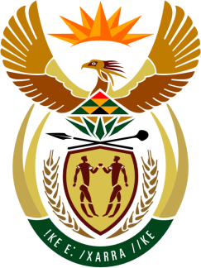

**SOUTH AFRICAN PERMANENT MISSION**

**TO THE UNITED NATIONS**

**AND OTHER INTERNATIONAL ORGANISATIONS**

**47th SESSION OF THE WORKING GROUP ON THE**

**UNIVERSAL PERIODIC REVIEW**

**Review of DOMINICA**

**7 November 2024**

**(2 MIN)**

**speaker no: 50**

***Check against delivery***

Mr. President,

South Africa welcomes the distinguished delegation of Dominica to this UPR Session.

My delegation commends Dominica for efforts made since the previous cycle of the UPR mechanism towards the advancement of human rights. South Africa is encouraged by the recent passing into law, in May 2023, the Domestic Violence Act, as well as the enactment of the Maintenance of Children Act No. 11 of 2023, the latter, which seeks to bring the law of Dominica in conformity with the United Nations Convention on the Rights of the Child (CRC). In this respect, my delegation wishes Dominica success in the effective implementation of its new laws.

Mr President,

South Africa wishes to make the following recommendations to Dominica:

1. Establish a national human rights institution for the promotion and protection of human rights, in line with the Paris Principles,
2. Redouble efforts to reduce infant mortality, as envisioned by Sustainable Development Goal No. 3.2,
3. Align the minimum age of marriage for girls and boys to 18, without setting exceptions.

South Africa wishes Dominica a successful review.

I thank you.