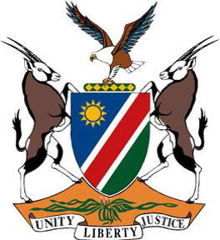

**Statement by Namibia at the 47th Session of the UPR Working Group:**

**Review of Dominica, 07 November 2024**

**Mr. President,**

1. Namibia warmly welcomes the esteemed delegation of Dominica.
2. We commend Dominica for its vision to become the first climate-resilient nation in the world, and for promulgating three key documents aligned with the Sustainable Development Goals, to realize that goal. We further commend Dominica for adopting several relevant acts to protect women and children, specifically the Domestic Violence Act No. 14 of 2023.
3. In the spirit of constructive dialogue, we wish to offer the following recommendations:

**First,** establish a national human rights institution for the promotion and protection of human rights, in line with the Paris Principles

**Second,** ratify the International Covenant on Civil and Political Rights and its Second Optional Protocol, aiming at the abolition of the death penalty

**Third,** ratify the International Covenant on Economic, Social and Cultural Rights

**Fourth,** ratify the Convention against Torture and Other Cruel, Inhuman or Degrading Treatment or Punishment

We wish Dominica a successful fourth review.

**Thank you!**