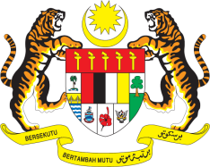

**STATEMENT BY MALAYSIA**

**REVIEW OF DOMINICA**

**47TH SESSION OF THE UPR WORKING GROUP**

**4 – 15 NOVEMBER 2024**

Malaysia thanks Dominica for the presentation of its national report.

1. Malaysia commends Dominica on the establishment of the National Mechanism for Reporting and Follow-up (NMIRF) in 2019 to facilitate the implementation of recommendations made in previous UPR cycles. Despite facing economic and social challenges, resulting from pandemics and natural disasters, Dominica has made great strides in promoting and protecting human rights.
2. In the spirit of constructive engagement, Malaysia recommends the following:
   1. First, continue efforts to strengthen its public health system in supporting families, households and vulnerable individuals, including through its National Resilience Development Strategy; and
   2. Second, pursue efforts to address the impacts of climate change, including by integrating the unique vulnerabilities and needs of women, children, older persons and persons with disabilities in climate change strategies.
3. We wish Dominica a successful review.

Thank you.

**7 NOVEMBER 2024**

**GENEVA**