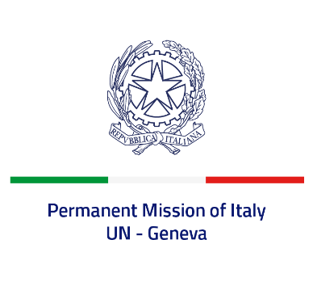

*Check against delivery*

**UPR 47 – Dominica**

**Thursday 7 November 2024, 9:00 – 12:30**

**Delivered by:  Permanent Representative of Italy Amb. Vincenzo Grassi**

Thank you, Mister President.

We thank the distinguished delegation of Dominica for their national report and presentation.

Italy commends Dominica for the establishment of the *National Mechanisms for Implementation, Reporting and Follow-up* and for the accession to both the *International Convention for the Protection of All Persons from Enforced Disappearance* and the *International Convention on the Elimination of All Forms of Racial Discrimination*.

Italy welcomes the fact that Dominica has a de facto moratorium on the use of the death penalty and commends it for its recent steps showing commitment to a full moratorium. We also noted favourably the measures taken to protect women from violence, such as the Domestic Violence Act, as well as the efforts made to promote the rights of indigenous people.

Italy seizes this opportunity to offer Dominica the following recommendations:

*- Continue fighting against sexual violence and domestic violence;*

*- Ensure through adequate legislative and social measures the full protection of children's rights, including by providing specific tools for situations of vulnerability;*

*- Take measures to decriminalize homosexuality and promote positive action against discrimination;*

*- Consider removing the remaining legislative provisions, first and foremost Article 5 of the Criminal Code, which still authorise the use of capital punishment.*

We wish Dominica a successful review. I thank you.