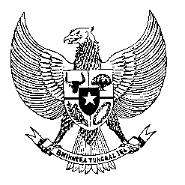

Permanent Mission

of the Republic of Indonesia to the UN, WTO,

and Other International Organizations

in Geneva

**STATEMENT BY THE DELEGATION OF THE REPUBLIC OF INDONESIA**

**AT THE 47th SESSION OF THE UPR WORKING GROUP**

**CONSIDERATION OF THE UPR REPORT OF DOMINICA**

1. **NOVEMBER 2024**

* **Thank you Mr. Vice-President,**
* Indonesia warmly welcomes the delegations of Dominica and thanks them for the report.
* We commend Dominica’s progress and commitment to human rights and encourage continued efforts to improve.
* We appreciate Dominica’s vision to become the first climate-resilient nation and hope that policy implementation will ensure the protection of its vulnerable populations.
* Additionally, we note Dominica’s progress in providing free healthcare services at all levels. However, continued support is needed to expand coverage for mothers and children and improve access in rural areas.
* We also acknowledge Dominica’s commitment to disability rights, and warmly welcome its ratification of the CRPD.
* In a spirit of constructive engagement, we recommend to Dominica as follows:

1. Strengthen the capacity and resources of the National Commission for Persons with Disabilities to enable it to effectively implement the CRPD;
2. Enhance access to quality and equitable healthcare in rural areas, focusing on maternal and child health services.
3. Accede to the UN Convention against Torture and Other Cruel, Inhuman or Degrading Treatment or Punishment.

Indonesia wishes Dominica success in its UPR.

**Thank you.**