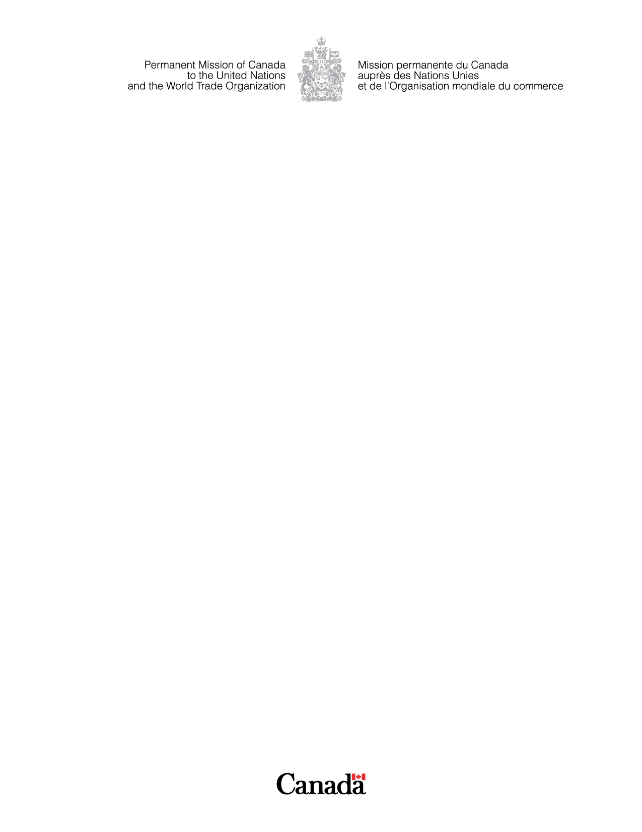
47th Session of the Universal Periodic Review

COMMONWEALTH OF DOMINICA

Thank you, Mister President.

Canada welcomes Dominica’s delegation to this Universal Periodic Review and thanks Dominica for the presentation of its report.

Canada commends Dominica on the decriminalization of consensual same-sex sexual activity.

Canada recommends that Dominica:

- Enhance protection from violence against vulnerable populations by enforcing the Revised Domestic Violence Act and carrying out public awareness campaigns.
- Adopt the Sexual and Reproductive Health Policy accompanied by sufficient financial resources and training for healthcare workers to deliver quality, adolescent-friendly health services.
- Abolish the death penalty.
- Advance protections for LGBTQI+ persons by prohibiting discrimination.

Canada encourages Dominica to establish a national human rights institution and address the backlog of requests for registration of civil society organizations.

