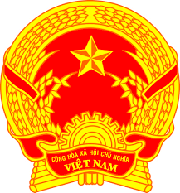
Statement of the Socialist Republic of Viet Nam
47th Session of the UPR Working Group
Review of Côte d’Ivoire
(Geneva, 05 November 2024)

Mister President,
Viet Nam welcomes and thanks the delegation of Côte d’Ivoire for the presentation of the national UPR report.
We commend Côte d’Ivoire for its endeavor to strengthen human rights institutional and legislative framework. We also appreciate Cote d’Ivoire’s efforts to promote human rights education for the public and public servants.
In a spirit of constructive dialogue, Viet Nam makes two recommendations to Côte d’Ivoire:
First, continue to strengthen its socio-economic development and allocate sufficient resources to ensure the right to health and the right to education for the people.
Second, continue its efforts to advance gender equality and women empowerment through awareness-raising and assistance programs.
Viet Nam wishes Côte d’Ivoire every success with this UPR cycle.
Thank you, Mister President./.

