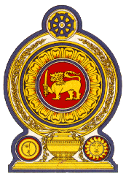

**47th Session of the Universal Periodic Review**

**Review of Côte d’Ivoire**

**05 November 2024**

**Statement by the Democratic Socialist Republic of Sri Lanka**

Mr President,

Sri Lanka welcomes the delegation of Côte d’Ivoire and the presentation made.

We commend Côte d’Ivoire’s progress in protecting and promoting human rights since its last UPR. Sri Lanka notes with appreciation the policy level measures taken to promote the enjoyment of human rights including the implementation of the National Development Programme, Government Social Programme, National Child Protection Policy and the National Action Plan to Combat Trafficking in Children.

In a constructive spirit, Sri Lanka recommends that Côte d’Ivoire:

-Promotes the rights of the child by ensuring their safety and access to education.

-Continues to advance the rights of women including protection from exploitation, harassment and gender-based violence.

We wish Côte d’Ivoire success in its UPR engagement.