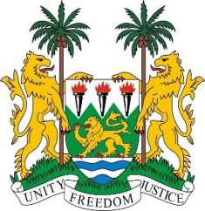

**SIERRA LEONE**

**47th Session of the UPR**

**REVIEW OF COTE D’IVOIRE**

Tuesday, 5 November 2024

**Check against delivery.**

1minute 15 seconds

Sierra Leone welcomes and thanks **H.E. Mr. Jean Sansan KAMBILE Minister of Justice and Human Rights,** and the distinguished delegation from the Republic of Côte d’Ivoire for presenting its national report.

My delegation commends La Côte d'Ivoire for its efforts in promoting compulsory education. We applaud the strategic plan to accelerate girls' education and the "Schools for All" programme. We acknowledge the country's endorsement of multiple international human rights instruments and its submission of reports to relevant treaty bodies.

We commend La Côte d'Ivoire for ratifying the Optional Protocol to the Convention against Torture and the Second Optional Protocol to the International Covenant on Civil and Political Rights, which aims to abolish the death penalty. We also recognise the country's other domestic legislation and policies that are aligned with its international human rights commitments.

In a constructive spirit, we offer the following recommendations for La Cote d’Ivoire’s consideration.

1. Continue strengthening measures to implement cross-political dialogue and transitional justice mechanisms.
2. Consider enacting a law on gender parity to ensure equal representation of women and men in both the public and private sectors.
3. Enhance the protection and fulfilment of the rights of vulnerable groups, including women, children, and persons with disabilities.
4. expedite the adoption of policies providing alternatives to custodial sentences for misdemeanour offences.

Sierra Leone wishes La Côte d'Ivoire the a successful fourth-cycle review.

**Thank you, Mr President**.