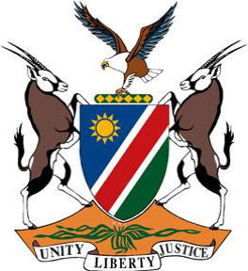

**Statement by Namibia at the 47th Session of the UPR Working Group:**

**Review of Côte d'Ivoire, 05 November 2024**

**Mr. President,**

1. We warmly welcome the distinguished delegation of Côte d'Ivoire and wish them a successful fourth review.
2. Namibia commends Côte d'Ivoire for ratifying the Second Optional Protocol to the International Covenant on Civil and Political Rights aiming at the abolition of the death penalty. We further welcome Côte d'Ivoire’s efforts to improve its institutional and legal framework aimed at accelerating the elimination of discrimination against women and promoting gender equality.
3. In the spirit of constructive dialogue and engagement, we respectfully offer the following recommendations:

**First,** ratify the Optional Protocol to the International Covenant on Economic, Social and Cultural Rights, the Optional Protocol to the Convention on the Rights of the Child on a communications procedure, and the Optional Protocol to the Convention on the Rights of Persons with Disabilities;

**Second,** promote girls’ access to education at all levels as a basis for their empowerment; and

**Third,** ensure that women and girls with disabilities are included in all policies and programmes on gender.

**Thank you for your attention**