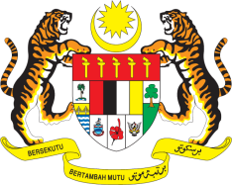

**STATEMENT BY MALAYSIA**

**REVIEW OF CÔTE D'IVOIRE**

**47TH SESSION OF THE UPR WORKING GROUP**

**4 – 15 NOVEMBER 2024**

Malaysia thanks Côte d'Ivoire for the presentation of its national report.

1. Malaysia commends Côte d'Ivoire on its steadfast commitment to improve its legal framework and promote human rights education in the country. We note the challenges faced by Côte d'Ivoire in prison management and in implementing alternatives to detention.
2. In the spirit of constructive engagement, Malaysia recommends the following:
   1. First, strengthen efforts to improve prison conditions and reinforce measures taken to reintegrate prisoners into the community;
   2. Second, enhance measures to eradicate child labour, including through strengthening legal and policy framework; and
   3. Third, continue steps to strengthen domestic legislation to combat sexual exploitation of children, including online sexual abuses.
3. We wish Côte d'Ivoire a successful review.

Thank you.

**5 NOVEMBER 2024**

**GENEVA**