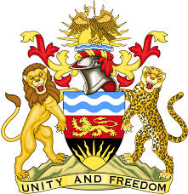

**REPUBLIC OF MALAWI**

**MALAWI STATEMENT ON CÔTE D’IVOIRE UNIVERSAL PERIODIC REVIEW**

**TUESDAY, 5TH NOVEMBER 2024**

**Mr. President**,

Malawi welcomes Côte d’Ivoire to this review and thanks the delegation for the comprehensive presentation. We commend Côte d’Ivoire for the strides made in the promotion and protection of human rights.

In the spirit of constructive dialogue, Malawi makes the following recommendations to Côte d’Ivoire:

1. Step up efforts to ratify the Optional Protocol to the International Covenant on Economic, Social and Cultural Rights;
2. Consider ratifying the Optional Protocol to the Convention on the Rights of the Child on a communications procedure; and
3. Consider ratifying the Optional Protocol to the Convention on the Rights of Persons with Disabilities.

We wish Côte d’Ivoire all the best at this review and in the implementation of the recommendations.

**Thank you, Mr. President**.