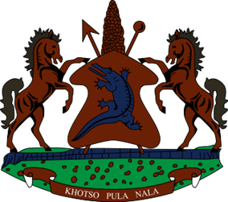

**STATEMENT BY THE KINGDOM OF LESOTHO DURING THE 4TH UPR REVIEW OF** **COTE D’IVOIRE**

**05 NOVEMBER 2024**

**Thank you, Mr. President,**

Lesotho welcomes the distinguished delegation of Cote d’Ivoire to the working Group and thanks them for the presentation of their Report. We note with appreciation the measures put in place by the Government of Cote d’Ivoire to promote and protect human rights of its citizens. Lesotho applauds Cote d’Ivoire for efforts made to strengthen the full exercise of human rights, through the implementation of public policies such as the National Climate Change Adaptation Plan among others. We welcome efforts made to submit periodic reports before the AU and UN treaty bodies.

In a constructive spirit, Lesotho wishes to make the following recommendations to the delegation of Cote d’Ivoire. 1. to continue efforts to prohibit all forms of child labour in various sectors of the economy; 2. To redouble efforts to sensitize community leaders on the adverse effects of FGM and forced or early child marriages on the girl child and 3. To bolster efforts to investigate acts of violence against women and girls, including human trafficking and sexual exploitation.

Finally, we wish Cote d’Ivoire every success with this implementation of the recommendations emanating from this UPR cycle.