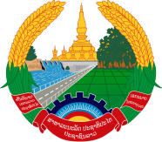

**Statement by the delegation of the Permanent Mission of the Lao PDR to the United Nations Office and other International Organizations in Geneva**

**At the 47th Session of the UPR Working Group**

**Geneva, 4-15 November 2024**

_________

**Review of Côte d’Ivoire, 5 November 2024 (14:30-18:00)**

* Mr. President,
* My delegation warmly welcomes the delegation of Côte d’Ivoire and thanks them for the comprehensive report.
* The Lao PDR appreciates the progress made by the Government of Côte d’Ivoire in the implementation of the accepted recommendations received during the previous cycle of UPR.
* In this constructive spirit, the Lao PDR would like to offer two recommendations:

1. Accelerate the effective implementation of the National Development Programme 2021-2025;
2. Continue efforts to promote the right to education to ensure equal access to quality education.

* We wish Côte d’Ivoire a successful review.
* I thank you, Mr. President.