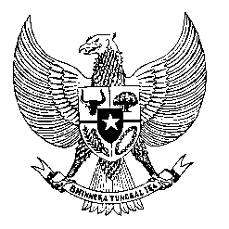

Permanent Mission

of the Republic of Indonesia to the UN, WTO,

and Other International Organizations

in Geneva

**STATEMENT BY THE DELEGATION OF THE REPUBLIC OF INDONESIA**

**AT THE 47th SESSION OF THE UPR WORKING GROUP**

**CONSIDERATION OF THE UPR REPORT OF**

**CÔTE D'IVOIRE**

**5 NOVEMBER 2024**

**Thank you, Mr. President,**

* Indonesia warmly welcomes the delegation from Côte d'Ivoire and extends our appreciation for presenting their report.
* We commend Côte d'Ivoire for its efforts to strengthen its legislative framework, aimed at improving the protection and fulfillment of human rights for its citizens.
* We also appreciate Côte d'Ivoire's initiatives to raise awareness and conduct targeted training to combat domestic violence, sexual violence, rape, forced and early marriages, and torture, focusing on key stakeholders across its society.
* In the spirit of constructive cooperation to further reinforce its human rights agenda, Indonesia recommends Côte d'Ivoire the following:

1. Strengthen and expand policies to alleviate poverty and empower women, ensuring robust social and labour protections for vulnerable populations.
2. Redouble efforts to fulfill economic, social, and cultural rights, fostering inclusive economic growth that amplifies access to healthcare, basic education, and employment opportunities.
3. Strengthen the laws and regulations to safeguard better access to freedom of peaceful assembly and freedom of expression.

We wish Côte d'Ivoire for a successful Universal Periodic Review.

Thank you.

*Word count: 172 words.*

*Speaking time: 1 minute and 15 seconds*