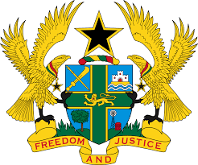

**STATEMENT DELIVERED BY GHANA DURING THE 47TH SESSION OF THE UNIVERSAL PERIODIC REVIEW (UPR) WORKING GROUP ON TUESDAY, 5TH NOVEMBER, 2024**

**UNIVERSAL PERIODIC REVIEW OF COTE D’IVOIRE**

Mr. President,

Ghana warmly welcomes our brothers and sisters from Cote d’Ivoire and commend their continued cooperation with human rights mechanisms.

2. We applaud Côte d’Ivoire for its firm commitment to tackle human trafficking, in particular, the efforts underway to adopt a manual on standard operating procedures for the prosecution of perpetrators of trafficking and the comprehensive care provided to victims of trafficking. We also acknowledge the bold initiatives introduced by Ivorian authorities in the area of good governance and the strengthening of the legal framework against corruption, including the implementation of the National Good Governance and Anti-Corruption Strategy.

3. In the spirit of constructive engagement, we make the following recommendations:

* **Ratify the Optional Protocol to the Convention on the Rights of Persons with Disabilities; and**
* **Strengthen prevention mechanisms to address drug use and create community programs to provide treatment for young addicts.**

4. Ghana wishes Cote d’Ivoire a very successful review.

I thank you.