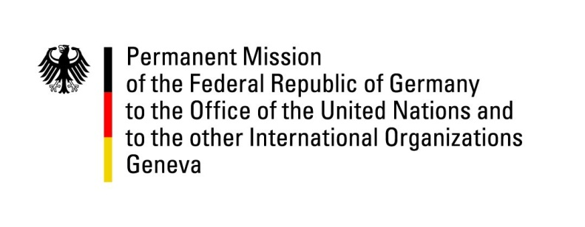

**United Nations Human Rights Council**

**47th Session of the UPR Working Group**

**Geneva, 5th of November 2024**

**German Recommendations and advance questions to**

**Côte d‘Ivoire**

Mister President,

Germany welcomes the delegation of Côte d‘Ivoire.

Germany commends Côte d‘Ivoire for the many steps taken since the last UPR to improve Human Rights. Among them, we applaud the reduction of child labor, especially in the cocoa sector and improvements regarding average attendance times in schools. We call upon Côte d’Ivoire to continue and enhance efforts to further reduce child labor in the country.

However, Germany views freedom of expression and assembly as an essential pillar of democracy and remains concerned that demonstration are frequently banned. While recognizing some progress on freedom of the press, access to judicial protection is hampered by restrictive admission to the bar and voter registration remain low.

Germany therefore recommends to:

* initiate effective measures to ensure the right to freedom of opinion and expression and the right to freedom of peaceful assembly and association, and to refrain from restrictions on exercising these rights.
* strengthen citizens’ rights for effective judicial protection, particularly by facilitating regulations on the enrolment in the Ordre national des avocats aiming for a significant increase in the number of lawyers and the availability of legal protection to everyone.
* strengthen democratic participation and correspondingly the social acceptance of elections by prolonging the time intervals for the registration of voters significantly.

Thank you, Mister President.

**GERMAN ADVANCE QUESTIONS TO CÔTE D'IVOIRE:**

* How many lawyers have been accepted into the Chamber “Ordre National des Avocats” in the last years? Which measures are planned to facilitate the access of new lawyers into the Chamber to improve the access to legal protection for the general public?
* During the third cycle, Côte d’Ivoire did not accept any of the proposed recommendations regarding the rights of LGBTI persons. Which steps have been taken in the meantime to increase public acceptance of LGBTI persons and their protection against discrimination in Côte d’Ivoire?
* With presidential elections scheduled for 2025, which preparatory measures is Côte d’Ivoire taking to ensure that elections will be conducted in a free, fair and transparent manner and in respect of every citizen’s right to participation? Is the state taking steps to guarantee accessibility for people with disabilities? Which measures have been or will be undertaken to increase the participation in the upcoming elections?
* With the evictions in parts of Abidjan in early 2024 thousands of people were left homeless. Which steps are taken to ensure these people will have access to shelter again? Will the promised compensation be enough for people to start over anew?
* With many changes in the State’s Penal Code, how will Côte d’Ivoire handle the ongoing problem of way too many detainees for the available spaces? Furthermore, how will the system be adjusted so that detainees and the guards know when a sentence is served and detainees don’t spend more time imprisoned than they are sentenced to?