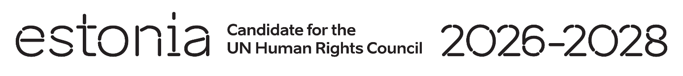

**Universal Periodic Review of C**ô**te d`Ivoire**

**5 November 2024**

**Intervention by the delegation of Estonia**

Estonia welcomes the delegation of Cote d`Ivoire to its forth UPR.

Estonia commends Côte d`Ivoire`s efforts to improve the human rights situation in the country by ratification of international human rights instruments and strengthening the legal and institutional framework on the enjoyment of human rights by women. However, Estonia expresses its concern on the realization of the right to freedom of expression, media freedom and peaceful assembly.

We recommend to:

* Revise the relevant articles of the Criminal Code to bring them into line with international standards on freedom of expression and peaceful assembly.
* Legalize abortion in cases of rape, incest or severe fetal impairment and decriminalize abortion in all other cases.
* Improve access to education for all, in particular to girls living in rural areas and carry out awareness raising activities on girls` right to education.

Estonia wishes Côte d`Ivoire a successful review.

Thank you!