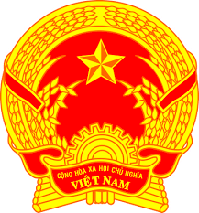
Statement of the Socialist Republic of Viet Nam
47th Session of the UPR Working Group
Review of Costa Rica
(Geneva, 11 November 2024)

Mr. President,

Viet Nam warmly welcomes the delegation of Costa Rica and commends the country’s ongoing commitment to advancing and protecting human rights. We appreciate Costa Rica’s efforts to update its legal framework, integrate the human rights education into school curricula and public service training, and adopt the National Policy for Children and Adolescents 2024–2036.
In the spirit of constructive engagement, Viet Nam recommends that Costa Rica:
- Enhance measures to prevent and address all forms of violence, including gender-based violence, particularly in remote areas;
- Expand initiatives to reduce poverty and inequality through targeted social programs;
- Strengthen policies and support systems that promote the inclusion and rights of persons with disabilities.
Viet Nam wishes Costa Rica success in this UPR cycle.
Thank you, Mr. President./.

