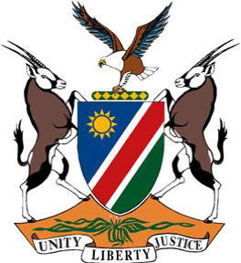

**Statement by Namibia at the 47th Session of the UPR Working Group:**

**Review of Costa Rica, 11 November 2024**

**Mr. President,**

1. Namibia warmly welcomes the delegation of Costa Rica to the 4th cycle of the UPR. We applaud Costa Rica for mainstreaming gender equality and human rights in the National Development and Public Investment Plan for 2023–2026. We further welcome the adoption in 2022 of the Act on Affirmative Action for Persons of African Descent.
2. In the spirit of constructive dialogue, Namibia recommends that Costa Rica:

**One,** implement a strategy to ensure that all Indigenous children, children of African descent, migrant children and children with disabilities are registered at birth

**Two,** strengthen the institutional architecture and management of the National Council of Persons with Disabilities and ensure that it maintains its autonomy

**Three,** develop a national strategy on deinstitutionalization of persons with disabilities.

We wish the delegation of Costa Rica a successful fourth review.

**I thank you!**