*Check against delivery*

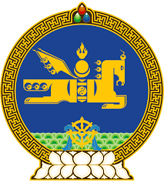

**47th SESSION OF THE UPR WORKING GROUP**

**MONGOLIA’S STATEMENT AT THE REVIEW OF COSTA RICA**

**11 November 2024, 09:00 - 12:30 hrs**

(1 min 15 sec)

Mr. President,

Mongolia welcomes the Delegation of Costa Rica to the 4th cycle of the UPR and thanks them for the presentation of their national report.

We commend the host of measures Costa Rica has undertaken to safeguard children and those in vulnerable situations, including through introduction of relevant policies and procedures. We welcome the adoption of the Road Map to Make Costa Rica a Country Free of Child Labour and its Worst Forms for 2022–2025 in this regard and encourage its effective implementation.

In the spirit of constructive dialogue, Mongolia recommends Costa Rica the following:

**One.** To strengthen legal protection for women and girls in situations of gender-based violence, and enhance the effectiveness of preventive measures and victim support services, in particular in rural and remote areas;

**Two.** To consider developing a national plan for the early detection and treatment of life-threatening conditions in children, and step up awareness campaigns for children and adolescents on the harms of drug use;

**Three.** To take necessary measures to remove all barriers to access to justice for persons with disabilities.

We wish Costa Rica every success in this cycle of the UPR review.

I thank you.

---oOo---