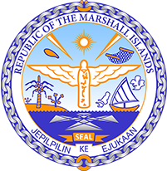

**Republic of the Marshall Islands**

**STATEMENT by H.E Ambassador Doreen deBrum**

**47th Session Universal Periodic Review**

**11 November 2024**

**Geneva**

4th Cycle Review of Costa Rica

*Check against delivery*

Thank you, Mr. President.

The Republic of the Marshall Islands welcomes the esteemed delegation of Costa Rica and thanks them for the report.

We commend Costa Rica for their efforts in pursuing sustainable development alongside the advancement of human rights. In particular, we commend its leadership in environmental protection at the international level including through its active engagement in the High Ambition Coalition and by spearheading the international recognition of the human right to a clean, healthy and sustainable environment.

In the spirit of constructive dialogue, we recommend the following:

1. Continue to ensure that indigenous peoples are meaningfully engaged in the development of legislation, national policies and programmes on climate change and environmental protection;

2. Adopt a comprehensive policy for the protection of environmental and human rights defenders with strategies to prevent and investigate attacks against them;

3. Promote traditional knowledge and culture by incorporating Indigenous history, culture and languages in the national education curriculum.

We wish the delegation every success during its 4th UPR cycle.

Kommol tata and I thank you.