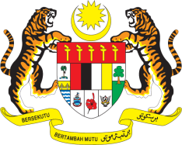

**STATEMENT BY MALAYSIA**

**REVIEW OF COSTA RICA**

**47TH SESSION OF THE UPR WORKING GROUP**

**4 – 15 NOVEMBER 2024**

Malaysia thanks Costa Rica for the presentation of its national report.

1. In the spirit of constructive engagement, Malaysia recommends the following:
   1. First, continue efforts to strengthen public security through capacity-building programmes for law enforcement agencies to combat organised crimes and violence;
   2. Second, implement a comprehensive policy to address school dropout rates in rural areas and among boys through community-based interventions or educational campaigns;
   3. Third, adopt a more inclusive policy on development by ensuring the full participation of marginalised communities and aligning its national development strategies with the right to development;
   4. Fourth, effectively implement strategies to protect the rights of Indigenous Peoples, including addressing poverty, combating violence and providing access to a quality healthcare system; and
   5. Fifth, enhance strategies to address the impacts of climate change, including by integrating the unique vulnerabilities and needs of women, children, older persons and persons with disabilities in climate change strategies.

Thank you.

**11 NOVEMBER 2024**

**GENEVA**