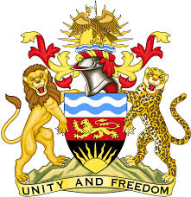

**REPUBLIC OF MALAWI**

**MALAWI STATEMENT ON COSTA RICA UNIVERSAL PERIODIC REVIEW**

**MONDAY, 11TH NOVEMBER 2024**

**Mr. President**,

Malawi welcomes Costa Rica to this review and thanks the delegation for the comprehensive presentation. We commend Costa Rica for taking significant steps in the promotion and protection of human rights.

In the spirit of constructive dialogue, Malawi makes the following recommendations to Costa Rica:

1. Expedite the adoption of the draft framework law to prevent and punish all forms of discrimination, racism and intolerance, incorporating disability as a prohibited ground in the definition of discrimination and references to multiple and intersecting forms of discrimination;
2. Consider raising the minimum age of criminal responsibility and ensure the full application of juvenile justice; and
3. Promote women’s access to formal employment and extend social protection schemes to women employed in the informal economy.

We wish Costa Rica all the best at this review and in the implementation of the recommendations.

**Thank you, Mr. President**.