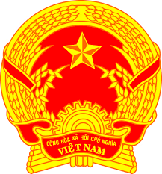

**Statement of the Socialist Republic of Viet Nam**

*47th Session of the UPR Working Group  
Review of Albania*

*(Geneva, 4 November 2024)*

*Mister President,*

Viet Nam warmly welcomes the delegation of Albania and appreciates their national UPR report.

We commend Albania’s efforts in strengthening its human rights framework, particularly through initiatives like the National Strategy for European Development and Integration 2022–2030 and the enhanced measures for gender equality and anti-discrimination.

In the spirit of constructive dialogue, Viet Nam would like to make two recommendations:

1. Continue advancing accessibility and inclusion in education, ensuring equal opportunities for all, especially for marginalized communities as well as people with disabilities.

2. Further enhance the transparency and efficiency of public services by expanding initiatives such as e-governance and digital inclusion, building on Albania’s efforts under the Digital Agenda of Albania 2022-2026.

We wish Albania a successful UPR cycle.

*Thank you, Mister President.*

***Time: 1 minute 35 seconds***