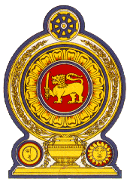

47th Session of the Universal Periodic Review

**Review of Albania** – 4 November 2024

Statement by the Democratic Socialist Republic of Sri Lanka

Mr. President,

Sri Lanka thanks the delegation of Albania for the presentation made today.

Sri Lanka notes the measures taken by Albania towards strengthening its human rights framework since the last UPR including the several sectoral/cross-sectoral strategies pertaining to human rights.

Sri Lanka recommends that Albania;

1. Strengthen efforts to combat human trafficking particularly through allocation of required resources and training of relevant public officials.
2. Consider providing inclusive and accessible shelters for victims of domestic violence with expertise in treatment and rehabilitation.
3. Implement necessary reforms to eliminate all forms of discrimination against the Roma community and the ethnic minorities.
4. Address all existing gaps and challenges in providing equal access to health, education, adequate housing and improving living conditions of the minority communities.
5. Protect children from all forms of economic exploitation including child labour through necessary legislative, policy and other interventions.

We wish Albania success in its UPR engagement.