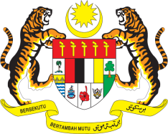

**STATEMENT BY MALAYSIA**

**REVIEW OF ALBANIA**

**47TH SESSION OF THE UPR WORKING GROUP**

**4 – 15 NOVEMBER 2024**

Malaysia thanks Albania for the presentation of its national report.

1. Malaysia notes Albania’s progress in advancing human rights, particularly through key legislative measures aimed at reforming its judicial system, improving the welfare of persons with disabilities and combating human trafficking. Malaysia encourages Albania to continue aligning its national efforts with its broader international commitments and the shared priorities of political groups it belongs to, including the OIC.
2. In the spirit of constructive engagement, Malaysia recommends the following:
   1. First, implement comprehensive policies and a national plan of action to eliminate mother-to-child transmission of HIV and provide access to quality health services for women, children and families, particularly the minority groups such as the Roma community;
   2. Second, ensure full and effective implementation of anti-discriminatory laws, particularly for marginalised groups like the Roma community; and
   3. Third, expand the availability and accessibility of shelters and support services for victims of domestic and sexual violence, particularly in rural areas.
3. We wish Albania a successful review.

Thank you.

**4 NOVEMBER 2024**

**GENEVA**