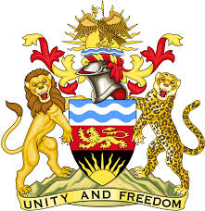

**REPUBLIC OF MALAWI**

**MALAWI STATEMENT ON ALBANIA UNIVERSAL PERIODIC REVIEW**

**MONDAY, 4TH NOVEMBER 2024**

**Mr. President**,

Malawi welcomes Albania to this review and thanks the delegation for the comprehensive presentation.

In the spirit of constructive dialogue, Malawi makes the following recommendations to Albania:

1. Consider ratifying the International Labour Organization (ILO) Domestic Workers Convention, 2011;
2. Consider fully implementing the National Agenda for Child Rights and Protection; and
3. Consider applying new models of administration, restorative justice and diversion measures in the new Juvenile Justice Code and Law on the Rights of the Child.

We wish Albania all the best at this review and in the implementation of the recommendations.

**Thank you, Mr. President**.