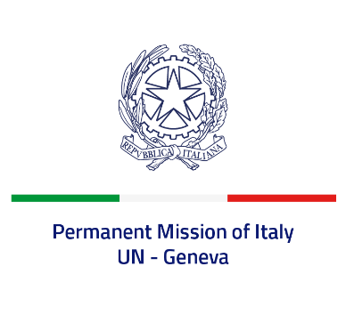

*Check against delivery*

**UPR 47 – Albania**

**Monday 4 November 2024, 14:30 – 18:00**

**Delivered by:  Permanent Representative of Italy Amb. Vincenzo Grassi**

Thank you, Mister President.

We thank the distinguished delegation of Albania for their national report and presentation.

Italy welcomes the reform of the judicial system and the creation of the online portal (*E-Albania*) as fundamental initiatives to fight corruption in the country and improve the independence, efficiency and transparency of the public sector. We also noted favourably the continued efforts to strengthen the protection of the rights of the child, including in the juvenile criminal justice sector.

Italy seizes this opportunity to offer Albania the following recommendations:

- *Fully implement the reform of the judicial system, also in the context of the Albanian accession to the European Union;*

- *Take further measures to combat domestic violence, including by fully implementing the existing legislation and by guaranteeing that women victims of violence can access legal aid and social services*;

- *Continue to implement the Action Plan on the Rights of Persons with Disabilities, thus ensuring the right to inclusive education and public spaces for all children with disabilities*;

- *Continue to devote attention to guaranteeing the full enjoyment of the rights of children, including by granting access to education and health, especially in rural and remote areas*.

We wish Albania a successful review.

I thank you.