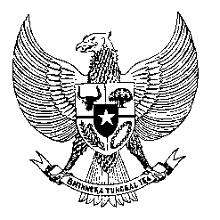

Permanent Mission

of the Republic of Indonesia to the UN, WTO,

and Other International Organizations

in Geneva

**STATEMENT BY THE DELEGATION OF THE REPUBLIC OF INDONESIA**

**AT THE 47th SESSION OF THE UPR WORKING GROUP**

**REVIEW OF ALBANIA**

**4 NOVEMBER 2024**

**Thank you, Madam Vice-President,**

Indonesia welcomes Albania’s participation in its 4th cycle of UPR and thanks for its report.

We acknowledge Albania’s continued efforts to strengthen the promotion and protection of human rights by updating the relevant national strategies and action plans since its last UPR.

However, the continued cases of racist hate speech and hate crimes in Albania remain concerning and it is highly important for Albania to seriously address this issue in line with its obligation as a State Party to the ICERD.

While noting Albania’s progress in other areas of human rights, we further wish that Albania’s strong commitment to human rights in the domestic level also resonates towards full support for human rights of the Palestinian people in the OPT.

For human rights improvement in Albania, Indonesia offers the following recommendations:

1. Adopt stronger measures to implement the law on protection from discrimination to prevent, deter and punish all forms of racism, including racist hate speech and hate crimes, online and offline.
2. Strengthen law enforcement actions to effectively combat trafficking in persons, especially women and children, including through increased budget allocation for prevention and prosecution.
3. Continue efforts to ensure the conditions of prisons and detentions in conformity with the international standards.

Finally, we wish Albania a successful UPR.

Thank you.

*Word Count: 209 words*

*Max. Speaking Time: 1 minute 35 seconds*