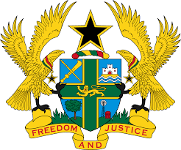

**STATEMENT DELIVERED BY GHANA DURING THE 47TH SESSION OF THE UNIVERSAL PERIODIC REVIEW WORKING GROUP ON MONDAY, 4TH NOVEMBER, 2024**

**UNIVERSAL PERIODIC REVIEW OF ALBANIA**

Madam Vice President,

2. Ghana extends a warm welcome to the distinguished delegation of Albania. We commend Albania for its constructive and stabilizing role in the Western Balkans which, we believe, has contributed to generating a positive momentum for its ongoing accession talks with the European Union.

3. We further applaud the Albanian Government's firm commitment to criminal justice reform, especially the efforts underway to amend the Criminal Code to address domestic violence and other crimes. Additionally, we recognize the measures undertaken by the government to ensure citizens have access to water and sanitation and, in that regard, commend the implementation of the National Strategy for the Water Supply and Sewerage Sector 2023-2030.

4. In the spirit of constructive dialogue, Ghana recommends that Albania:

1. **Ratify the Optional Protocol to the Convention on the Rights of Persons with Disabilities; and**
2. **Develop and implement measurable and targeted support programmes to address specific barriers faced by vulnerable groups, particularly migrants, refugees and asylum-seekers, including by ensuring that their treatment meet international human rights standards.**

5. Ghana wishes Albania a successful review.

I thank you.