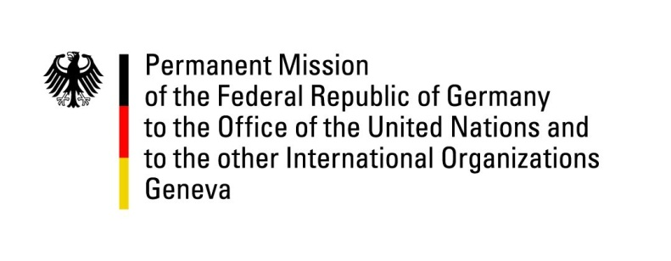

**United Nations Human Rights Council**

**47th Session of the UPR Working Group**

**Geneva, 4November 2024**

**German Recommendations to Albania**

Mister President,

Germany welcomes the delegation of Albania and appreciates Albania’s efforts to better protect and support victims of domestic violence, in particular women and girls, both nationally and internationally. We particularly welcome the introduction of national referral mechanisms monitoring the handling of abuse cases in all Albanian municipalities as well as Albania’s support for the CEDAW initiative regarding Afghanistan.

Germany strongly encourages Albania to improve the human rights situation of persons in detention undergoing compulsory psychiatric treatment. The circumstances of their detention and treatment continue to fall below human rights standards.

Despite having a lively media landscape, there remains substantial room for improvement in Albanian laws regarding the prosecution of crimes committed against journalists.

To strengthen Albania’s institutional framework for human rights, Germany therefore recommends to:

* continue efforts to improve the situation of detained persons, in particular by establishing an institution for forensic psychiatric patients under the Ministry of Health, and by improving psychiatric and psychosocial services in other places of detention; and
* to implement effective measures to promote media plurality and to safeguard freedom of expression and independent reporting, particularly by ensuring the protection of journalists against intimidation and harassment.

Thank you, Mr. President.