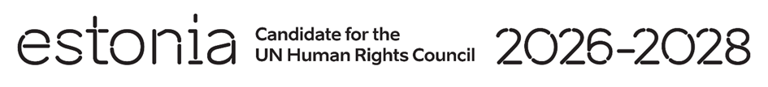

**Universal Periodic Review of Albania**

**4 November 2024**

**Intervention by the delegation of Estonia**

Estonia welcomes the delegation of Albania to its fourth UPR and commends Albania’s active role as a member in the Human Rights Council. We thank Albania for its national report and the information provided today.

We commend Albania for the measures taken to strengthen the fight against organized crime and corruption. Estonia welcomes all comprehensive legislative changes to address the gender-based violence and domestic violence. We encourage further efforts to implement the laws and policies related to the protection of children from violence at the central and local levels.

We would like recommend to Albania to:

* enact legislation to prohibit child, early and forced marriage, ensuring that the minimum age for marriage is set at 18 years;
* fully implement the current National Agenda for Child Rights and Protection for 2021-2026 and the legal provisions prohibiting corporal punishment in all settings;
* increase the availability of legal aid, shelter and counseling services for girls and women victims of domestic violence, and ensure that all regions have access to at least one specialized center;
* continue implementing the Strategy against Organized Crime and Serious Crimes 2021–2025 and its Action Plan, and swiftly adopt the new draft 2024–2030 Strategy in the fight against corruption.

We wish Albania a successful review.

Thank you.