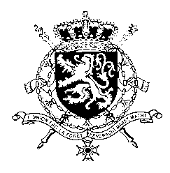
Représentation permanente de la Belgique auprès des Nations Unies et auprès des institutions spécialisées à Genève

WG UPR 47 – Albania
Belgian intervention
4 November 2024

President,
Belgium welcomes the efforts and positive steps made by Albania since its previous UPR, in particular the progress in relation to gender equality and the public participation of women.
Notwithstanding these efforts, important challenges remain, in particular regarding gender based violence, discrimination of minorities and media freedom and the protection of journalists.
Belgium therefore recommends the government of Albania to:
R1. Ensure effective and full implementation of court decisions in cases of international child abductions and to ensure compliance with its international commitments
R2. Amend the definition of rape for it to be based on lack of consent, instead of force or threat, in line with international standards and further strengthen the fight against gender based and domestic violence, including prevention and protection measures for survivors
R3. Align Albanian legislation with the recently adopted EU anti-SLAPP directive and ensure that journalists are protected from intimidation and harassment, and that incidents are thoroughly investigated and prosecuted, and victims receive proper compensation
Thank you, President

