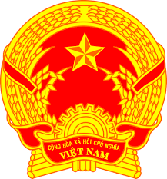

**Statement of the Socialist Republic of Viet Nam**

*46th Session of the UPR Working Group  
Review of Yemen*

*(Geneva, 01 May 2024)*

*Mister President,*

Viet Nam welcomes and thanks the delegation of Yemen for the presentation of the national UPR report.

We appreciate Yemen’s efforts to consolidate its institutional framework on human rights, including the establishment of human right units and departments under several governmental agencies. We also commend Yemen’s efforts to promote human right education to raise awareness and build capacity for governmental officials and the public.

In a constructive spirit, Viet Nam makes two recommendations to Yemen:

First, enhance its efforts to promote socio-economic development, eradicate poverty and prioritize resources to ensure the right to most essential services, including food, sanitation and medical care.

Second, continue to promote girls’ access to school, reduce the gender gap in education as well as enhance the participation of women in political, economic and social life.

In conclusion, Viet Nam wishes Yemen every success with this UPR cycle.

*Thank you, Mister President./.*

**Word count: 148 (1 min 14 sec/1 min 15 sec)**