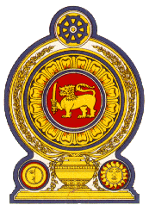

**46th Session of the Universal Periodic Review**

**Review of Yemen**

**01 May 2024**

**Statement by the Democratic Socialist Republic of Sri Lanka**

Mr President,

Sri Lanka thanks the delegation of Yemen for their presentation.

We appreciate the ongoing efforts by the Government of Yemen for peaceful settlement of the conflict and economic stability.

Sri Lanka further takes note of policy and institutional measures taken to promote human rights through the National Review Committee and national consultations.

In a constructive spirit, Sri Lanka recommends Yemen;

* enhance protection for persons in detention.
* strengthen efforts to promote and protect human rights including the early establishment of the proposed national human rights institution
* Continue to progress with implementation of the programmes and projects to provide free education in coordination with all stakeholders

We wish Yemen all the success in its UPR engagement.