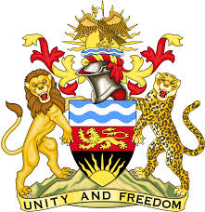

**REPUBLIC OF MALAWI**

**MALAWI STATEMENT ON YEMEN UNIVERSAL PERIODIC REVIEW**

**WEDNESDAY, 1ST MAY 2024**

**Mr. President**,

Malawi welcomes Yemen to this review and thanks the delegation for the comprehensive presentation.

In the spirit of constructive dialogue, Malawi makes the following recommendations:

1. Continue with the process of establishing a national human rights institution.
2. Continue with all efforts to protect human rights amidst the difficulties of conflict and the burdens of the transitional period.
3. Continue with measures to combat trafficking in persons, paying particular attention to the trafficking of women and children

.

We wish Yemen all the best at this review and in the implementation of the recommendations.

**Thank you, Mr. President**.