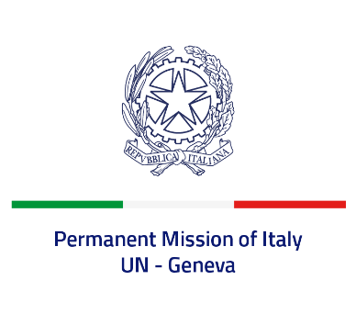

*Check against delivery*

**UPR 46 – Yemen**

**Wednesday 1 May 2024, 14:30 – 18:00**

**Delivered by: Permanent Representative of Italy Amb. Vincenzo Grassi**

Thank you, Mister President.

We thank the distinguished delegation of Yemen for their national report and presentation. Italy welcomes the commitment of Yemen to the UPR.

Italy would like to recommend to:

-  *Reduce the offences punishable by the death penalty, provide official figures regarding death sentences and executions, consider introducing a moratorium on the death penalty*;

- *Establish a minimum age of 18 for marriage and take effective action to combat gender-based violence and discrimination*;

*- Combat the practice of arbitrary arrest and detention, enforced disappearance and torture and other ill-treatment, investigate and prosecute those responsible and provide reparations for victims;*

*-  Fight against the recruitment of child soldiers by all armed groups and ensure that all persons below the age of 18 are released and reintegrated into their communities*;

*- Guarantee freedom of expression*;

- *Guarantee freedom of religion or belief*;

- *Ensure the protection of journalists and human rights activists*.

We wish the delegation of Yemen a successful review.

*I thank you.*