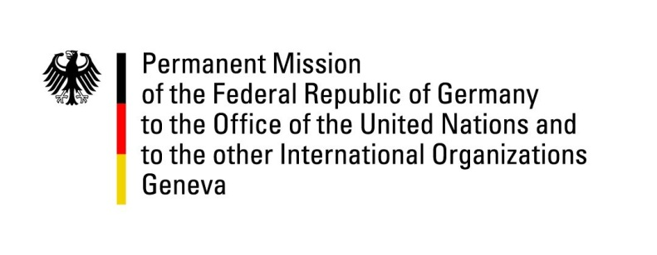

**United Nations Human Rights Council**

**46th Session of the UPR Working Group**

**Geneva, May 7, 2024**

**German Recommendations and advance questions to**

**Vietnam**

Mister President,

Germany welcomes the delegation of Vietnam and commends the adoption of Vietnam’s National Action Plan on Women, Peace and Security, as well as the country’s leadership in advancing economic, social and cultural rights through its work in this council.

However, Germany remains concerned about restrictions to freedom of speech and of freedom of religion or belief and the shrinking civil space in Vietnam, in particular for human rights defenders and environmental activists.

Germany therefore recommends Vietnam to

1. Ensure the participation of non-state actors and non-governmental organisations in the process of managing climate change and increase the number of non-governmental organisations in corresponding consultation mechanisms;
2. Ensure freedom of speech as provided for in the ICCPR, e.g. by examining amendments to articles 109, 117 and 331 of the Vietnamese penal code during its upcoming review;
3. Ratify ILO convention 87 as foreseen in the EU-Vietnam Free Trade Agreement and ensure its implementation~~;~~
4. Ensure that prison conditions are in line with applicable international legislation and the Vietnamese Ministry of Health’s national guidelines on minimum nutrition standards.

Thank you, Mister President.

**Germany’s Advance Questions to Vietnam**

1. Germany acknowledges Vietnam’s existing legislation on the rights of trans persons, as provided for by article 37 of the civil code, and Vietnam’s efforts to draft implementing legislation ensuring that trans people can change their assigned sex in identity documents. Where does Vietnam stand in this process and how can international partners support?
2. How many individuals have been prosecuted on charges related to articles 109, 117 and 331 of Vietnam’s penal code in the reporting period? How many of these have been released as innocent? How many of these convictions have been reviewed within the reporting period?
3. What measures has the government of Vietnam taken to ensure that non-governmental organisations and interested individuals can raise their opinions and concerns regarding climate change and climate policy?
4. How many claims of torture have been reported in the reporting period? How many of them have been investigated? How many have been confirmed and led to which consequences?
5. Which nutrition standards are currently in place in Vietnam’s prisons?
6. When will Vietnam ratify ILO convention 87 as foreseen in the EU-Vietnam Free Trade Agreement?