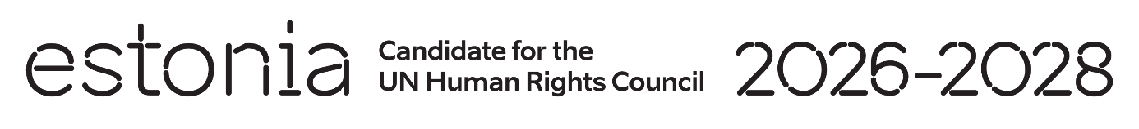

**Universal Periodic Review of the Yemen**

**1 May 2024**

**Intervention by the delegation of Estonia**

Estonia welcomes the delegation of the Yemen to its fourth UPR and thanks for the presentation of its national report.

We remain deeply concerned by the situation in Yemen, the humanitarian crisis, and the suffering of the Yemeni people. We condemn the violations of international human rights law and international humanitarian law. In particular, we are gravely disturbed by systematic violations of the rights of women and girls and by their widespread discrimination.

We are troubled by reports of the ongoing acts of violence, threats and harassment against journalists and media workers in Yemen and we strongly condemn all such intentional acts against journalists.

We would like to recommend to Yemen to:

* end the recruitment and use of children by armed forces, release all children from duty and ensure that they have access to protection and reintegration programs;
* criminalize all forms of gender-based violence against women, including sexual harassment, domestic violence, marital rape, child, early or forced marriage and female genital mutilation, without exemptions;
* establish an official moratorium on executions and ratify the Second Optional Protocol to the International Covenant on Civil and Political Rights.

Estonia wishes to the delegation of the Yemen a successful review.

Thank you!