ቀዋሚ ሚሽን ሃገረ ኤርትራ ናብ ውድብ ሕቡራት ሃገራት  ጀኔቫ | 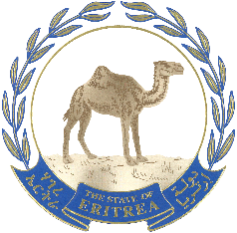  البعثة الدائمة لدولة إريتريا  لدى الأمم المتحدة | جنيف
Permanent Mission of the State of Eritrea to the United Nations
GENEVA

Eritrea’s statement during the Universal Periodic Review of the Republic of Yemen during the 46th session of the UPR Working Group
1 May, 2024

Mr. President,

Eritrea welcomes the esteemed delegation of the Republic of Yemen. In the spirit of brotherly solidarity, we wish to humbly share the following recommendations.

- Continue the efforts to build on national institutions for increasing people’s awareness of all sets of human rights and broaden the space for enjoyment of economic, social and cultural rights.
- Continue the efforts to give priority to the rights of the most vulnerable groups in society, especially women, children and persons with disabilities.

I thank you.

