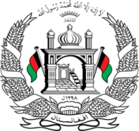

**Permanent Mission of Islamic Republic of Afghanistan**

**Session of the UPR Working Group**

**Statement on the Review of Yemen**

01 May 2024

**Mr./Mme. (Vice) President,**

Afghanistan warmly welcomes the distinguished delegation of Yemen to this meeting and thanks them for their detailed presentation of their national report.

We commend Yemen’s efforts for the implementation of the third cycle recommendation, despite the security challenges this brotherly country faces.

**Mr./Mme. (Vice) President,**

In the spirit of constructive engagement, my delegation wishes to make the following recommendations:

1. Take steps to combat impunity and effectively prevent, investigate, prosecute and punish all those responsible for attacks on civilian infrastructure, such as health-care facilities, food and water infrastructure, and schools

1. Assist in advocacy of recognizing the institutionalized regime of systematic oppression and discrimination against women and girls by the Taliban as 'gender apartheid', and advocate for the inclusion of gender apartheid as a crime against humanity in the Draft Articles on Prevention and Punishment of Crimes Against Humanity.

Finally, Afghanistan wishes Yemen every success in the review process.

**I thank you, Mr./Mme. (Vice) President.**