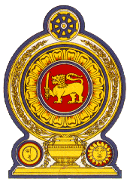

Statement by the Democratic Socialist Republic of Sri Lanka

46th Session of the Universal Periodic Review

**4th UPR Review – Viet Nam**

*07 May 2024*

Mr. President,

Sri Lanka appreciates constructive engagement and the comprehensive presentation by the Government of Viet Nam today.

We welcome Viet Nam’s accession to ILO Convention 98 on the Right to Organize and Collective Bargaining, ILO Convention 05 on the Abolition of Forced Labour, and joining the Global Compact for safe, orderly, and regular migration since its last UPR review.

We take positive note of Viet Nam considering accession to the Convention on the Protection of All Migrant Workers and Members of their Families and the Convention for the Protection of all Persons from Enforced Disappearance as recommended by Sri Lanka during the previous UPR review.

Mr. President, while noting these achievements, Sri Lanka recommends that Viet Nam:

* Implements further measures to combat trafficking in persons and introduces regulations to avoid fraudulent recruitment activities in the digital and cyberspace domains.
* Continues to take steps to enhance the quality of and access to primary healthcare services and raise awareness among people on primary healthcare facilities.
* Continues measures to enhance access to quality education including for children from socially vulnerable groups and enhance teaching and learning facilities for children with disabilities.

We wish Viet Nam success in its UPR engagement. Thank you.

Thank you.