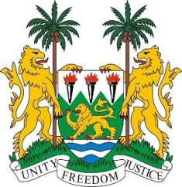

**SIERRA LEONE**

**46th Session of the UPR Statement**

**VIET NAM**

TUESDAY 7 May 2024

**Check against delivery.**

**Mr. President**,

Sierra Leone extends a warm welcome to **H.E. Mr. Do Hung Viet, Deputy Foreign Minister**, and the esteemed delegation of Vietnam, and thanks it for the presentation of its national report.

We commend Vietnam for its commitment to promoting gender equality and empowering women, as evidenced by the implementation of several key initiatives. We welcome the National Strategy on Gender Equality for 2021-2030 and the amended Law on the Prevention and Combating of Domestic Violence. These measures reflect Vietnam's commitment to addressing gender inequalities and ensuring the protection of women's rights.

It is noteworthy that Vietnam has made significant progress in gender equality, as evidenced by its improved ranking in the World Economic Forum's Global Gender Gap Report, where it ranked 72nd out of 146 countries in 2023.

We also commend the Government of Vietnam for its achievements in education, with all provinces and cities achieving universal secondary education and meeting universal primary education standards.

To address the existing human rights gaps, we offer the following recommendations:

1. Continue to actively implement measures to strengthen press freedom.

2.  Take decisive action to widen access to essential services such as health care, education, and basic amenities for marginalised communities.

3.  Implement targeted initiatives to address the specific educational needs of vulnerable groups, including persons with disabilities and children from disadvantaged backgrounds.

Sierra Leone extends its best wishes to Viet Nam Republic for a successful fourth cycle review.

**Thank you, Mr. President.**