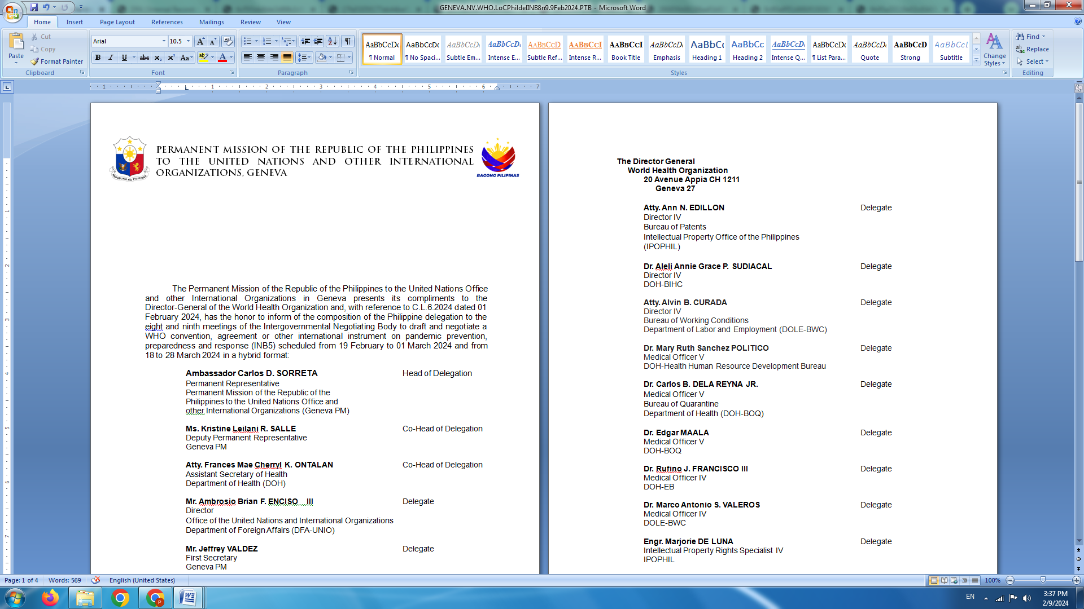

**P H I L I P P I N E S**

**HUMAN RIGHTS COUNCIL**

**46th Session of the Working Group on the Universal Periodic Review**

07 May 2024, Palais des Nations, Geneva, Switzerland

**REVIEW OF VIET NAM**

*To be delivered by*

**First Secretary Luningning Camoying Valdez**

*Speaking time: 50 seconds*

Mr. President,

The Philippines warmly welcomes the delegation of Viet Nam headed by Deputy Foreign Minister (Mr.) DO Hung Viet.

We laud Viet Nam’s determined efforts and progress in meeting the SDGs that led to significant improvements in the quality of life of its people, particularly in terms of access to education, health, and other basic social services.

As a close partner in ASEAN with similar vulnerabilities to climate change, the Philippines values its strong cooperation with Viet Nam in advocating for urgent and just climate actions in multilateral fora.

In the spirit of ASEAN solidarity, we offer the following recommendations:

1. Redouble efforts to promote gender equality and combat gender-based violence, including by enhancing contribution to the Council’s work in this area; and
2. Further strengthen mechanisms for the prevention and prosecution of human trafficking cases in line with international standards including those embodied in the ASEAN Convention.

We wish Viet Nam all success in this review. **END**