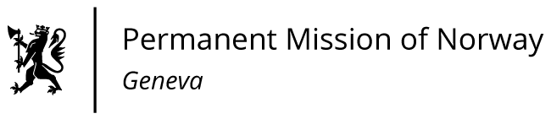

**STATEMENT**

**UPR 46 Session of the Human Rights Council**

**on the human rights situation in Vietnam,**

**as delivered by Mr Tormod C. ENDRESEN**

**Ambassador - Permanent Representative to the UN and other International Organizations.**   
**The Permanent Mission of Norway in Geneva.**

Check against delivery

7 May 2024

President,

Norway commends Vietnam’s efforts to improve the social and economic conditions for its people, [including the ratification of two ILO conventions]. However, we remain concerned about shrinking civic space [and increasing restrictions towards social organisations, journalists, and human rights defenders].

Norway recommends that Vietnam:

1. Ensures the right to freedom of expression, association and peaceful assembly and end practices of arbitrary arrests and detention of human rights defenders, political dissidents, and journalists.

2. Ensures that social organisations can engage fully and without risk of repercussions in the green transition.

3. Takes necessary measures to increase women's representation in executive bodies at national and local level, [aligning with the national strategy on gender equality 2021-2030.]

4. Establishes a moratorium on executions, working towards the repeal of the death penalty [in national legislation].

Thank you.