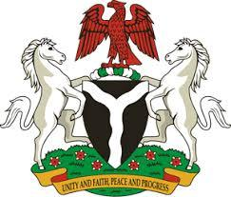

*Please check against delivery*

**HUMAN RIGHTS COUNCIL**

**46TH SESSION OF THE WORKING GROUP OF THE UPR**

**REVIEW OF VIET NAM**

**7TH MAY, 2024**

**STATEMENT BY NIGERIA**

**Mr. President,**

Nigeria welcomes the delegation of Viet Nam to the presentation of its National Report for the Fourth UPR Cycle and commends the Government on its commitment to international human rights obligations and human rights mechanisms.

2. Nigeria further commends the Government of Viet Nam for its unwavering commitment to economic development, which has significantly lifted many of its citizens out of poverty. Furthermore, the investments of the Government in education and healthcare have significantly enhanced the socio-economic well-being of its citizens.

3. In the spirit of constructive dialogue, Nigeria wishes to recommend to Viet Nam as follows:

1. To consider further necessary measures to ensure the protection of the rights of migrants, including through the ratification of the Convention on the Protection of the Rights of all Migrant Workers and Members of their Families; and
2. To intensify efforts to prevent and combat human trafficking while ensuring the promotion of the rights of victims of trafficking.

4. We wish Viet Nam a very successful review process.

I thank you, Mr. President.